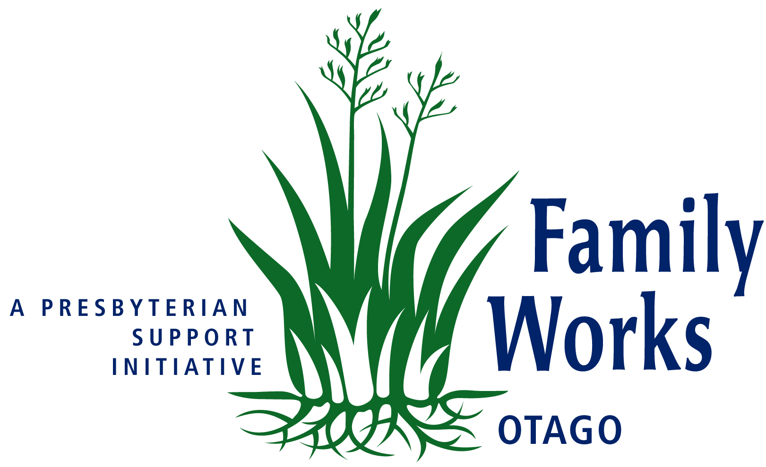Family Works Buddy Programme

To help us do the best for the child you have referred please provide us with the following information. The parents/caregivers must be aware of any referral made to the Buddy Programme and the child must consent to wanting a Buddy.
Full Name of Child Date: ___/____/_____

Address

Phone Email

Gender Male/Female Age DOB ____/____/___

NHI Number

Ethnicity if NZ Maori, What are your Tribal Affiliations
Cultural considerations

Name of Mother

Name of Father

Name of Caregivers

Marital Status of Parent\Caregiver(s)

Occupation of Parent\Caregiver(s)

Relationship to Child

Brothers, Sisters and their Ages

Emergency Contact Person and Phone Number?
Other Agencies involved with the family?

Agency Contact Person Ph No

Agency Contact Person Ph No

Why do you think the child needs a Buddy?

What do you hope the child will gain from having a Buddy?

FAMILY HISTORY:

MEDICAL HISTORY – eg. physical disability, medical conditions, medications, psychological diagnosis.

SCHOOL eg. School performance, behaviour. Name of school, teacher etc.

BUDDY HISTORY:

Safety risks that we should know about (eg dogs, physical hazards etc)

OTHER BACKGROUND INFORMATION including interests/activities eg. Anything you may wish to add that will help us match the child with a suitable Adult Buddy.

Parent/Caregivers consent to this referral Child has consented to having a Buddy

This Referral is endorsed by: _______________________________ (name of referrer)

Signature: _______________________ Agency: ______________________________

Phone : _________________________ Email: ______________________________

If you have any queries please phone the Buddy Programme Ph 477 7116

